CMP6200/DIG6200
Individual Undergraduate Project (FYP)
Final Progress Review
[Reinforcement Learning to improve AI
behaviour and adaptability in a game
environment]

Student Name: Tamer Hussen
Student ID: S23130437
Course: Computer Games Technology
Supervisor: Jan Krasniewicz
Reporting Period: [12/12/25] to [27/2/26]

Contents
1.0 Progress to Date - Summary 3
2.0 Artefact Design and Development 3
2.1 Implementation and Current State 3
2.2 Analysis and Reflection 6
3.0 Updated Planning for Project Completion 6
3.2 Draft Outline of Final Report 7
3.3 Abbreviations 7

Figure 1: Training Arena – Top-Down view 3
Figure 2: Training Arena – First person view 4
Figure 3: Main Game Scene – Top-Down View 4
Figure 4: Training Console Output 5
Figure 5: Video of ML agents training – Click image for video(Ctrl + Click on image) 5
Figure 6: Original Gantt Chart - link 7
Figure 7: Revised Gantt Chart - link 7

1.0 Progress to Date - Summary
The project is in advanced prototyping and controlled training. Core systems, including Unity scene, ML-Agents integration, PPO training pipeline, sensory systems (vision, hearing, multipoint scent trail), and a debug UI, have been implemented. Multiple training runs, checkpoints that have been exported to ONNX, have been executed and logged; early-stage learning shows strong positive mean rewards but extended training exhibits instability and low-reward plateaus. The main findings are that sensor integrity and reward shaping critically determine the learning quality. Therefore, recent work prioritises robust sensory signals, normalised observations and comparative evaluations against a scripted baseline. This progress directly addresses the following objectives:
- Objective 2 : Train and evaluate RL agent.
- Objective 4: Capture and visualise learning behaviour.
- Objective 5: Compare RL to scripted baseline (behaviour tree).

2.0 Artefact Design and Development

2.1 Implementation and Current State
Key implemented components and purpose:
- Environment and Assets: Simple arena scene, with obstacles, and solid and soft cover, used for incremental training complexity.
Yellow raycasts – show raycasts directions from enemy.
Orange raycasts – is the line of sight for the ML agent.
Green Trail – is a trail players leave temporarily, like a scent.
Wire Sphere – is the hearing range of the ML agent.
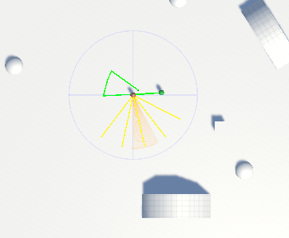
Green capsule is Player
Red capsule is ML agent.
Sphere – Temporary hiding spot.
Figure 1: Training Arena – Top-Down view
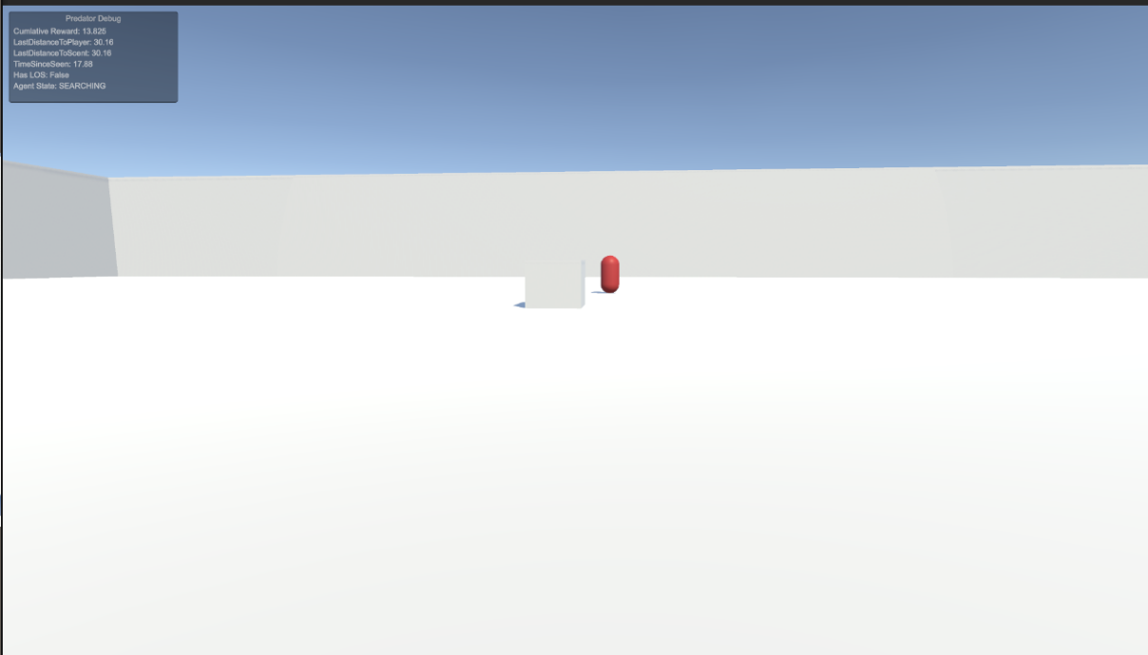
This is a temporary obstacle that helps with training the ML agent.
This is the ML agent searching for the player.
Debug UI – Used to show ML agent’s state, cumulative reward, distance and if player is in line of sight.
Figure 2: Training Arena – First person view
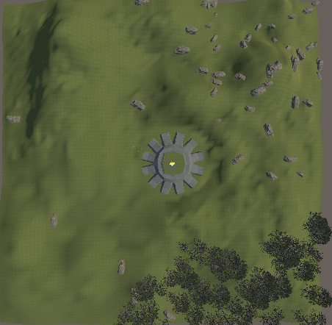
Stones – used as obstacles.
Foliage – some used as hiding spots.
Extended terrain area – space for player to explore and try to escape.
Central spawn arena – player and ML agent spawn area.
Figure 3: Main Game Scene – Top-Down View
- Predator Agent (RL): PPO agent with 35-dim normalised observation vector (distance, facing, raycasts, sound direction/volume, multi-point trail points), reward-shaping for approach, facing, LOS, and capture. ONNX exports produced at checkpoints.
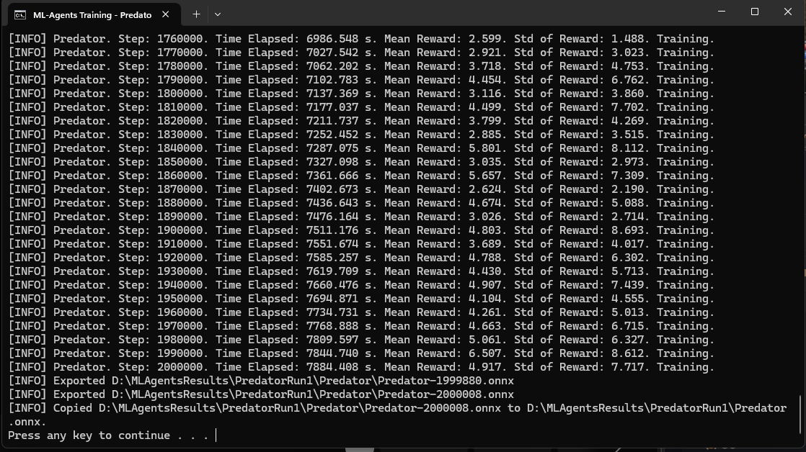
Figure 4: Training Console Output
This image shows the max steps for the training is 2 million steps, shows mean reward progression across training and demonstrates successful ONNX model export.
- Prey / Player: Player prefab with two modes: manual player movement and PreyAI (sprint and crouch produce varying sound levels and trail emission).
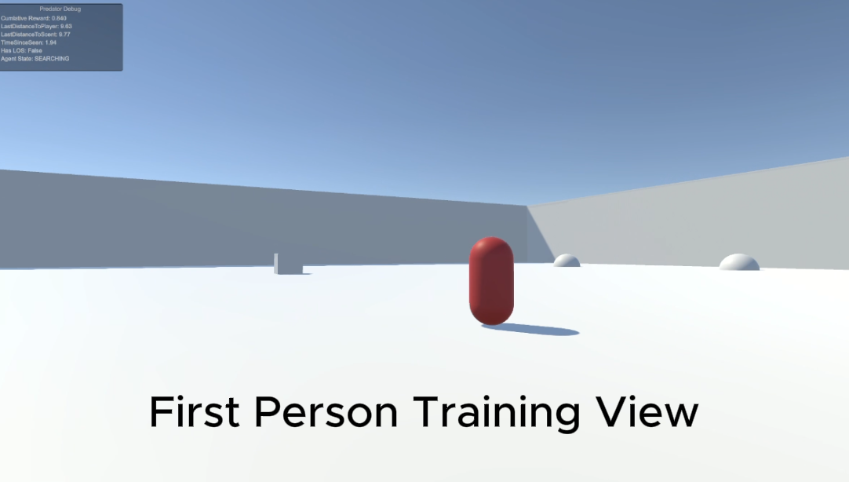
Figure 5: Video of ML agents training – Click image for video(Ctrl + Click on image)
The video shows the trained ML agent in pursuit, including top-down and first person training visuals, alongside a live debug showing the reward progression, distance, ml agent state and LOS state.
- Sensory Systems:
  - Vision cone with multi-ray raycasts and object-type encoding.
  - Hearing via SoundEmitter (volume, last position).
  - Multi-point TrailMarker (non-static list of points, timed sampling).
- Tools and Training: Learning configs are stored in YAML files with tuned hyperparameters, bat scripts for training, external log storage; debug UI displays, cumulative reward, LOS, distances and agent states during training.

2.2 Analysis and Reflection
- What works: Early learning produces coherent tracking behaviours when sensory inputs are consistent, and reward magnitudes balanced. Debug UI and normalised observations accelerated debugging.
- What doesn’t: Extended training often collapses into a low-reward plateau (local minima). Root causes identified:
  - noisy/static sensory emissions (fixed),
  - over-aggressive punishments.
  - large batch/buffer settings.
- Implications: RL can produce adaptive hunting but is sensitive to observation quality and reward balance, so a fair comparison requires a stabilised training procedure and a scripted baseline (behaviour tree) for a quantitative comparison.
- Design revision example: Trail and sound systems were refactored from static/random updates to frame-tied emissions and timed multipoint sampling; this directly improved early-stage learning behaviour and allowed meaningful reward signals.
This revised understanding shifted the project focus from algorithm selection toward reward design and environment stability as primary determinants of performance.

3.0 Updated Planning for Project Completion
- Stabilise training – run 3 controlled full trainings with final YAML (adjusted batch/buffer, time-horizon, learning-rate schedules) and pick best checkpoint.
- Implement baseline – build a Behaviour Tree (scripted AI) for direct comparison.
- Pilot testing and logging – planning questionnaire, recruit around 10 testers, collect gameplay logs (capture time, detection distance, success rate).
- Data analysis and visuals – prepare training curves, success-rate tables, and comparative stats.
- Write final report – draft Results, Discussion, Conclusion, incorporate supervisor feedback.
Target: stabilised training, baseline implemented and pilot data collected by 20/3/26 to allow analysis and report writing.
Figure 6: Original Gantt Chart - link
Figure 7: Revised Gantt Chart - link
The project timeline was revised to extended training, add a behaviour tree baseline for comparison and conduct structured pilot testing, which adjusted the mid phase dates without affecting the final submission deadline.

3.2 Draft Outline of Final Report
- Abstract
- Introduction and Problem Statement
- Literature Review (RL in games; baseline)
- System Design and Architecture (agents, sensors, reward design)
- Implementation (Unity, ML-Agents, YAML)
- Experimental Method (training regime, baseline, pilot tests)
- Results (training curves, metrics, ONNX checkpoints)
- Comparative Analysis (RL vs Behaviour Tree)
- Discussion ( limitations, generalisability)
- Conclusion and Future Work
- Appendices (logs, YAML, code excerpts)

3.3 Abbreviations
- RL – Reinforcement Learning.
- PPO – Proximal Policy Optimisation.
- ML-Agents – Machine Learning Agents.
- ONNX – Open Neural Network Exchange.
- LOS – Line of Sight.
- YAML – Yet Another Markup Language.

